

CA-1

CAP-785

WEB PERFORMANCE OPTIMIZATION

Submitted by - Submitted To –

NAME: Naseem Akhtar Faculty: Dr. Kamal Nain Sharma

REG NO: 12401725

SECTION: D2422

ROLL NO: 30

GROUP: 1

**Some snapshot of the web pages  
LINK -** [**https://naseem7888.github.io/web-performance/**](https://naseem7888.github.io/web-performance/)

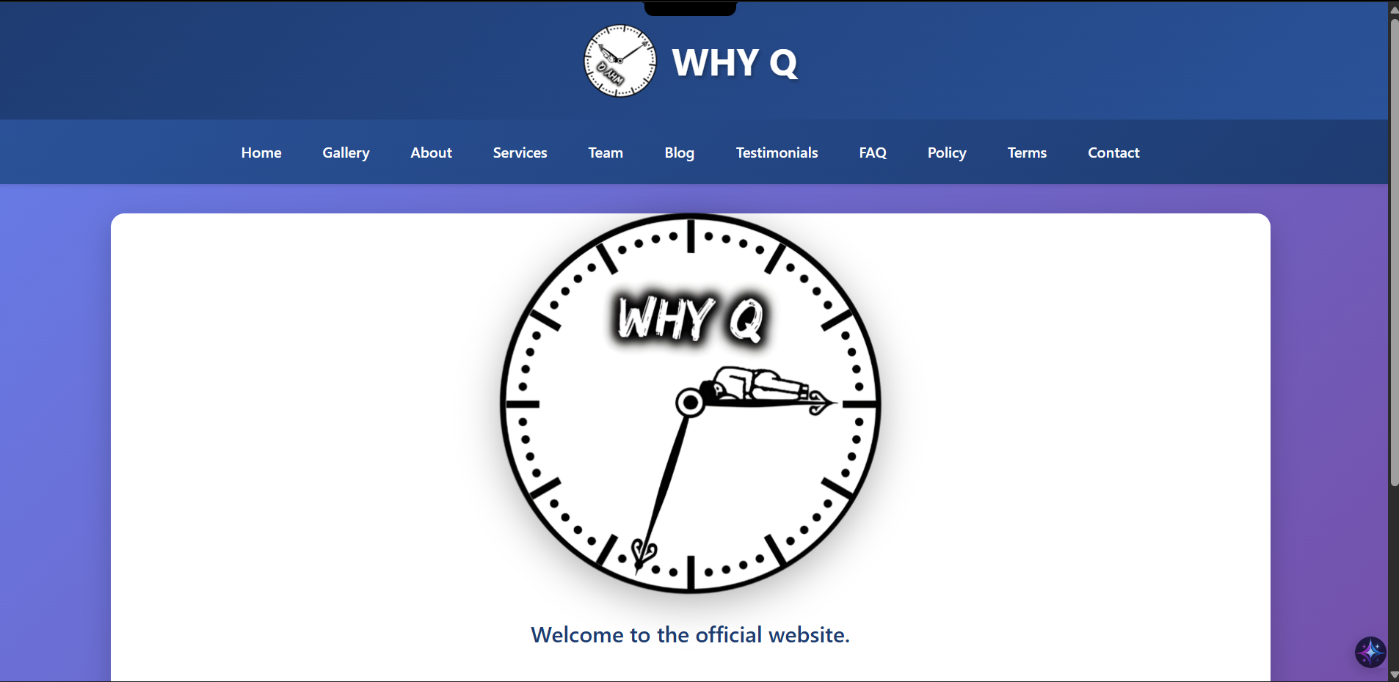

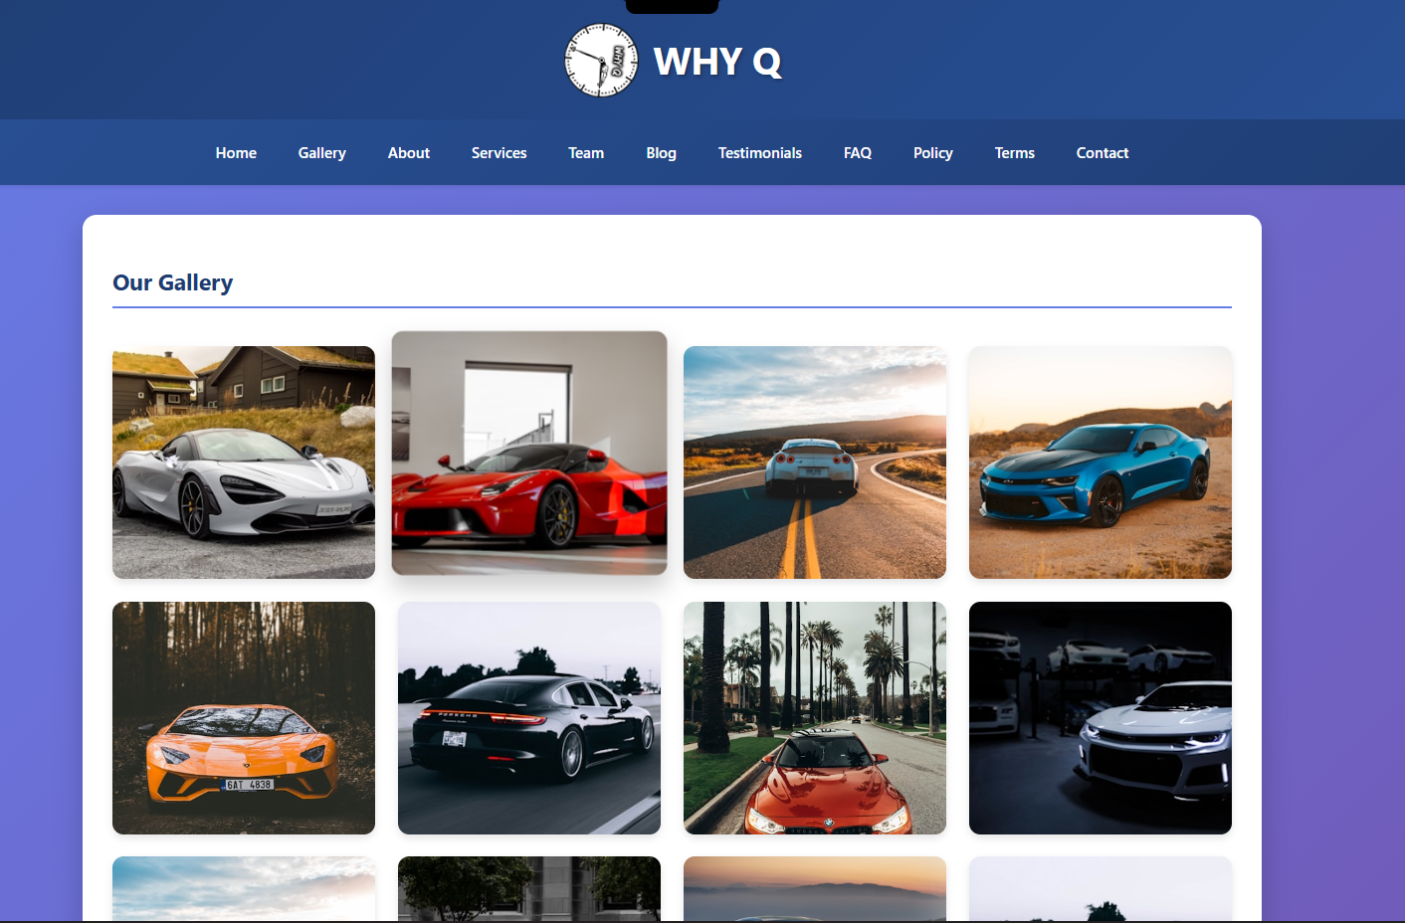

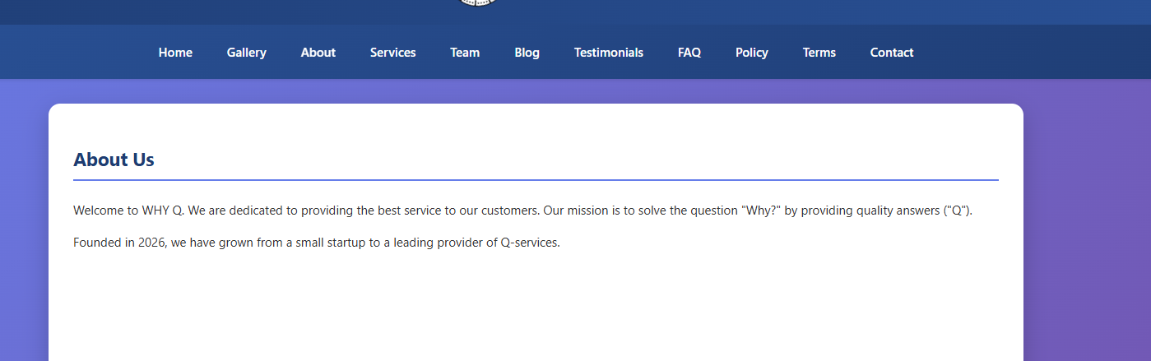   
  
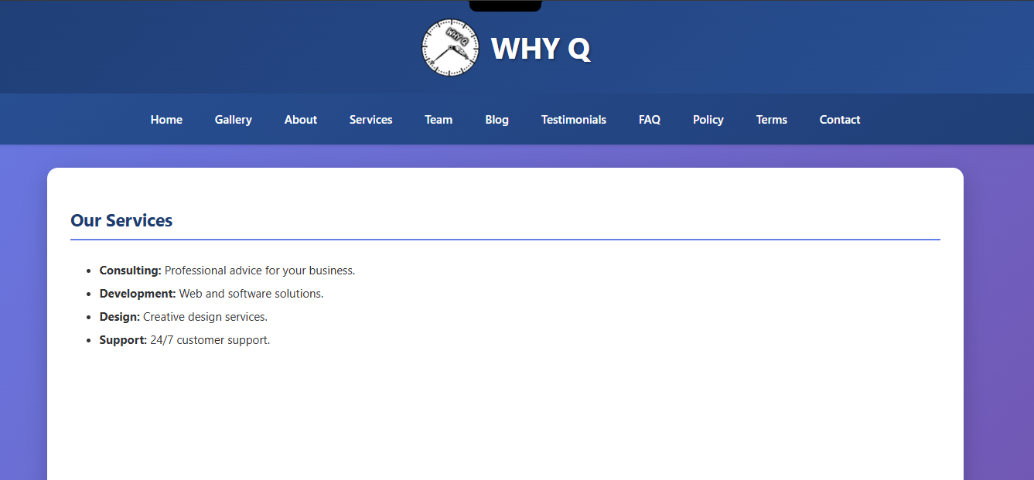  
  
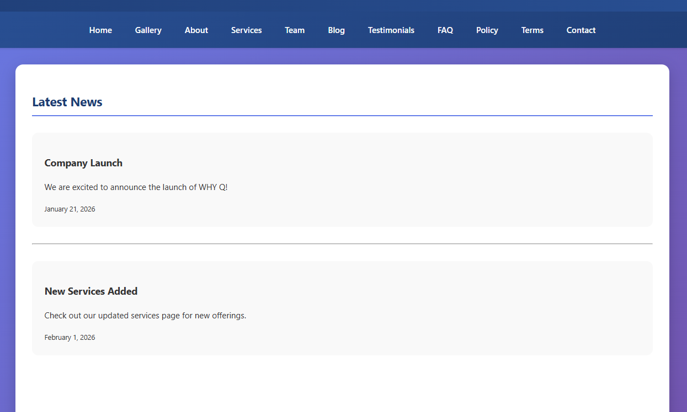

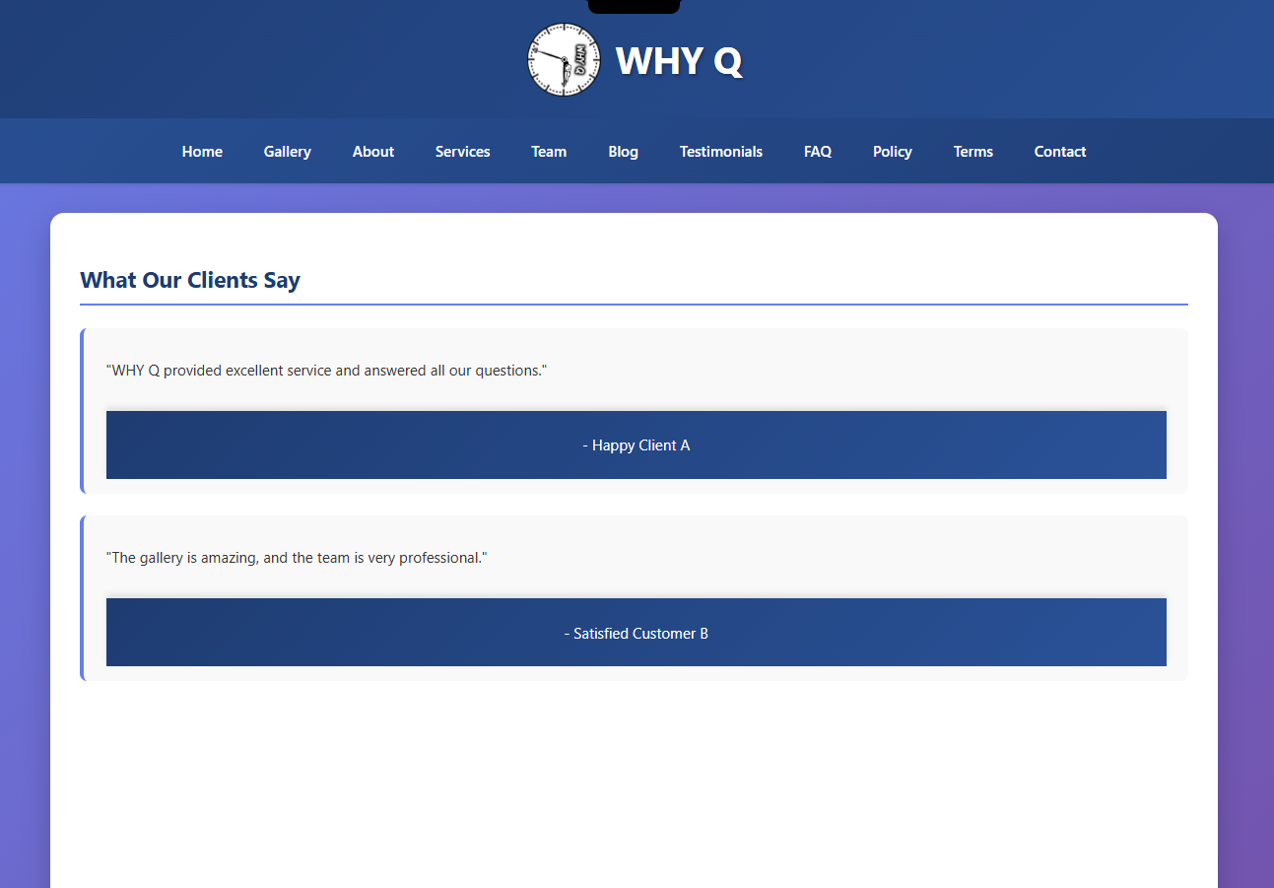

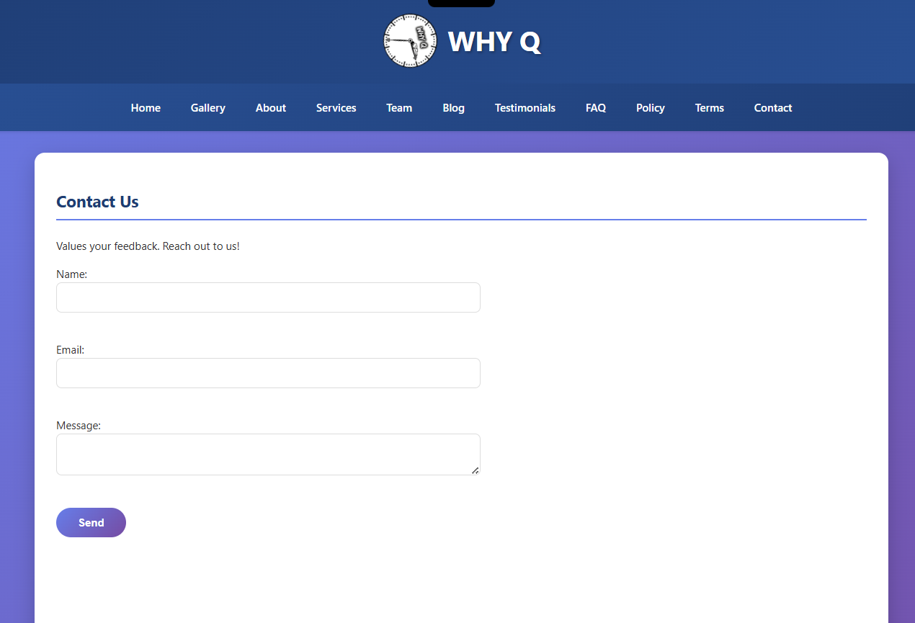

CODE (HTML) SNAPSHOT AND GITHUB REPO  
  
  
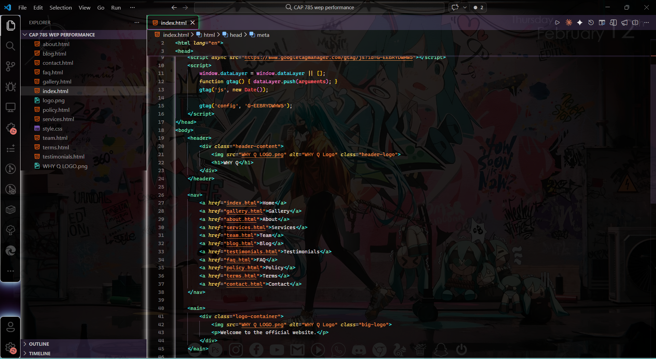

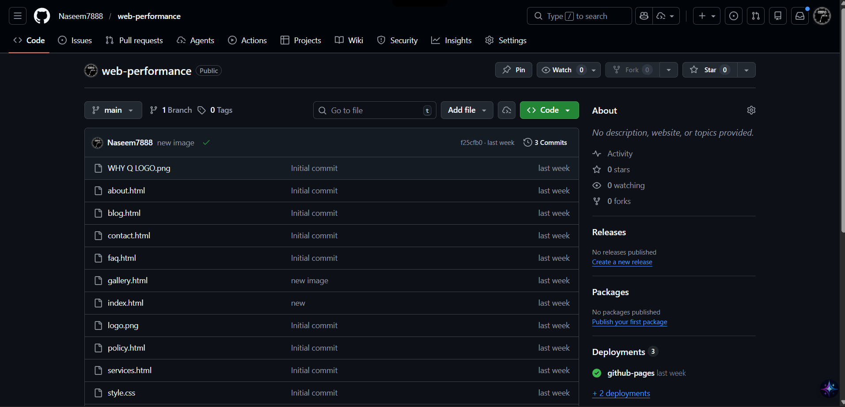

**Lazy landing implementation**

**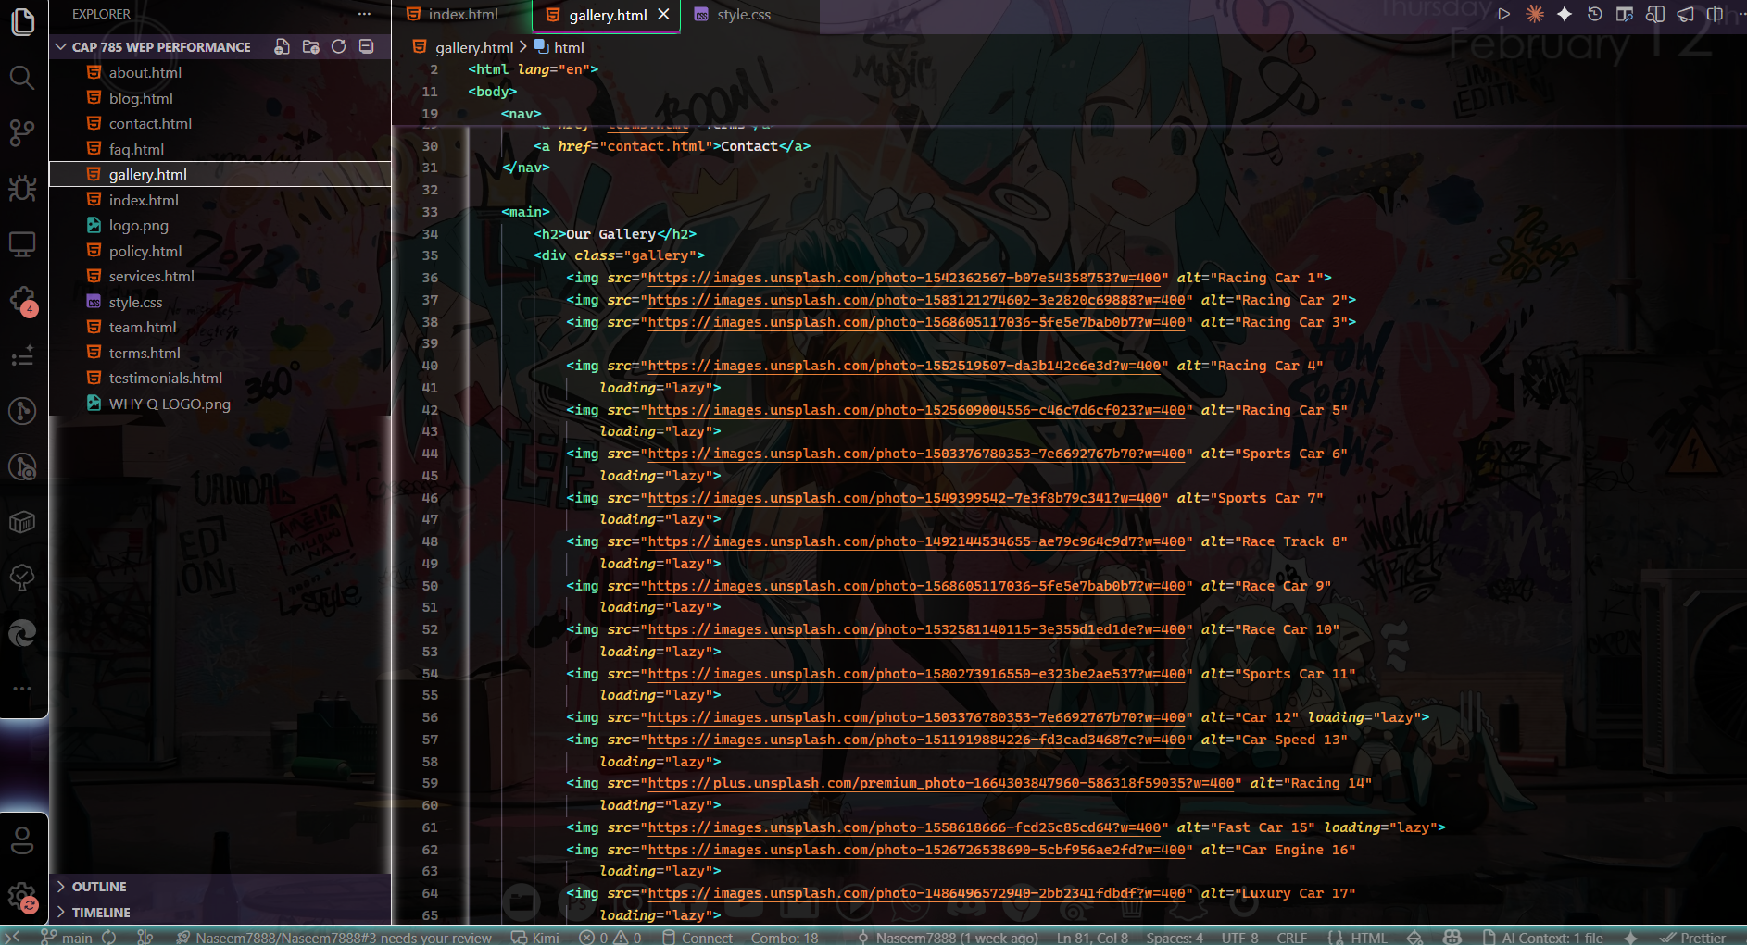  
  
Minification of css**

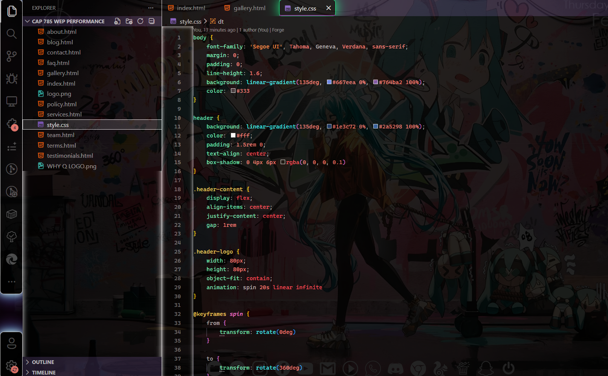

**PageSpeed Insights DEKSTOP**

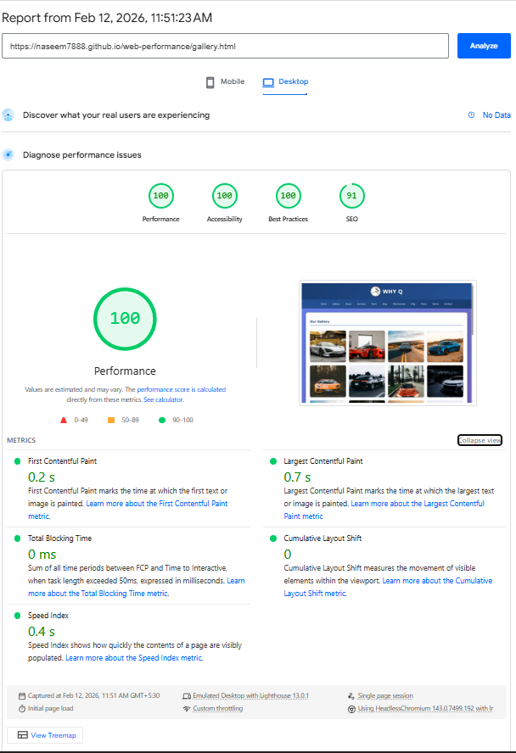

**PageSpeed Insights MOBILE  
  
